Excel guide 3 – (Bivariate) Relationships between variables

Before you start, make sure you install the Analysis toolpak (instructions on how to do so here: https://support.microsoft.com/en-us/office/load-the-analysis-toolpak-in-excel-6a63e598-cd6d-42e3-9317-6b40ba1a66b4)
- To check if it’s installed, click Data on the ribbon, and then see if there is a button for Data Analysis on the right:
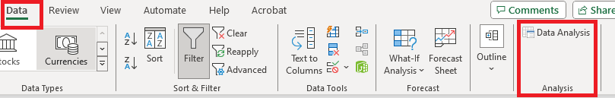

Relationship between two quantitative (continuous) variables
Correlation coefficients
- Arrange the two variables so that they appear next to each other (e.g., by copy-pasting to a blank part of the worksheet or a new worksheet)
- Under the Data tab, click “Data Analysis” (see screenshot above)
- Select “Correlation” and click OK
- Click inside the box for “Input Range,” then click to select the column you’re describing
- Make sure the box “Labels in first row” is selected (assuming you selected variables names as the first row)
- For “Output options,” I recommend “New Worksheet Ply”
Scatter plots
- Select the columns you’re describing
- Under the Insert tab, select a basic scatter chart (first option)
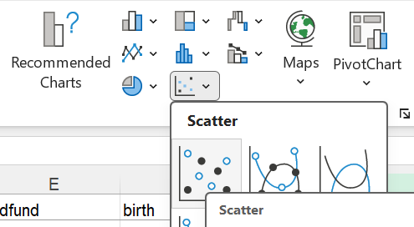
- Various formatting and labeling options can be adjusted to your liking
Relationship between two qualitative variables (sometimes it’s best to treat ordinal or discrete variables as qualitative, especially for visualization)
1. Make the initial pivot table
- Make sure your variables have names entered in the first row
- Under the Insert tab, click “PivotTable” (you may want to first select a cell within your dataset so that table/range automatically populates with your variables/observations)
- Make sure the variables/observations you want are selected in the box for “Table/Range”
- For choice of where you want the PivotTable, I recommend “New Worksheet”
- On the right, click-and-drag one of your variables to the box labeled “Rows” or “Axis”
- Click-and-drag your other variable to the box labeled “Columns” or “Legend”
- Click-and-drag one of these variables to the box labeled “Values”
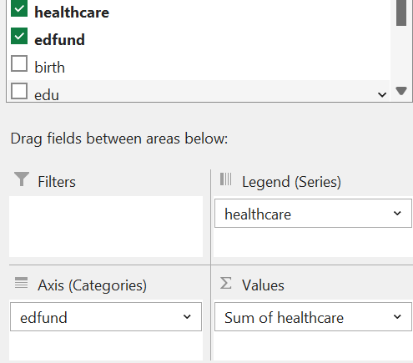
- In the Values box, click the small triangle to select, then choose “Value Field Settings”
- Select the “Count” option, then click OK
2. Make the bar chart
- A bar chart may automatically appear; if not, follow these steps:
  - Click any cell inside the pivot table
  - Under the Insert tab, click to add a Clustered Column chart (Clicking “Recommend Charts” may give you this as the default option)
- Alternatively, you may use a 100% Stacked Column chart (to alter the chart type: under the Design tab, click “Change Chart Type”)
- Make any desired adjustments to formatting/labeling, and then copy-paste the bar chart out of Excel before completing step 3 (step 3 will alter the bar chart by adding extra and unnecessary bars)
3. Add percentages to the pivot table
- Returning to “PivotTable Fields,” click-and-drag one of the variable names down to the box called “Values” again (the variable needs to be listed twice under “Values”)
- In the Values box, click the small “select” triangle for this second listing of your variable, and choose “Value Field Settings”
- Select the “Count” option, and then click on the “Show Values As” tab
- Select “% of Column Total” or “% of Row Total” (depending on how you prefer to calculate percentages)
- Near the top of the Value Field Settings box, type “%” in the “Custom Name” box, then click OK
- In the Values box, click the small “select” triangle for the first listing of your variable, and choose “Value Field Settings”
- Near the top of the Value Field Settings box, type “N” in the “Custom Name” box, then click OK
- Usually, crosstabs display percentages directly below the counts, so if that is not how they are currently displayed, you can adjust it: find the item labeled “Σ Values” (should be in the “Columns” or “Legend” box), and click-and-drag it to the “Rows” or “Axis” box

Relationship between a qualitative variable and a quantitative (continuous) variable (sometimes it’s best to treat ordinal or discrete variables as qualitative, especially for visualization)
1. Divide the sample into sub-samples by qualitative (or ordinal/discrete) variable
- Make sure you have a cell within your main dataset selected
- Under the Filter tab, click “Filter”
- Go to your qualitative variable. In row 1, click the small triangle to the right of the variable name. Change the selections such that just one value (the first value) is selected for this variable.
- Now, only a subset of your sample will be displayed. Select the column for your other variable of interest (the quantitative/continuous variable). Copy-paste this column to a new portion of your workbook (e.g., a new worksheet).
- Rename the newly-create column to reflect both the quantitative variable and the value of the qualitative variable.
- Repeat steps 3-5 for the next value of the qualitative variable. Repeat until all values of the qualitative variable have been covered. In the end, you should have a separate column for each value of the qualitative variable (e.g., race in the figure below), and the cells should indicate the values of the quantitative variable (e.g., estimate delivery rate for the usps in the figure below, ranging from 0% to 100%):
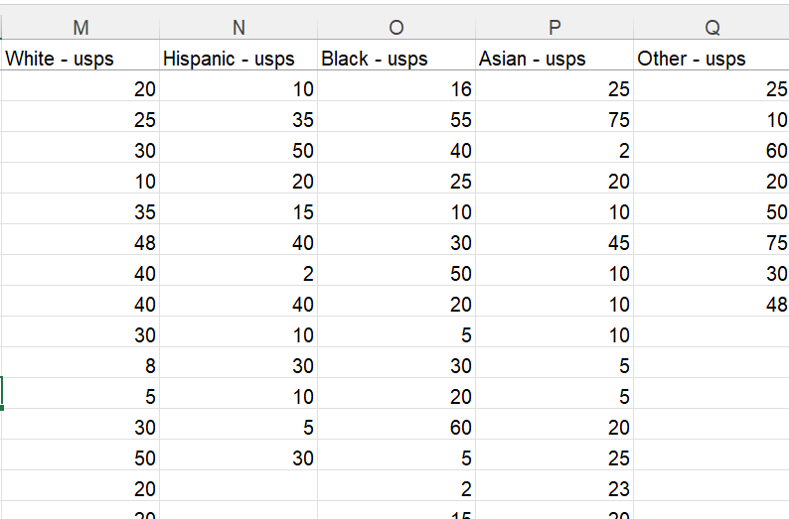
2. Create box plots
- Select all of the newly-created columns
- Under the Insert tab, select statistical charts and choose Box and Whisker
3. Add comparison of means/variances (through ANOVA)
- Under the Data tab, click “Data Analysis”
- Select “Anova: Single Factor” and click OK
- Click inside the box for “Input Range,” then click to select the column you’re describing
- Make sure the box “Labels in first row” is selected (assuming you selected variables names as the first row)
- For “Output options,” I recommend “New Worksheet Ply”

